ENQUIRY FOR PREQUALIFICATION (NO. PRQ/JPT/37/26)

STRUCTURES A & E, MELLITAH COMPLEX EXPANSION & CO2 MANAGEMENT INTEGRATED DEVELOPMENT PROJECT

EPIC for SEALINES AND SUBSEA SYSTEMS FOR STRUCTURES E and CO2 (WP4B1)

Mellitah Oil & Gas B.V. (MOG) intends to enhance its production by adding new offshore and onshore production facilities, under STRUCTURES A & E, MELLITAH COMPLEX EXPANSION & CO2 MANAGEMENT INTEGRATED Development Project. The Overall Development will be implemented on individual projects basis; including an EPIC Project for SEALINES AND SUBSEA SYSTEMS related to the production platform E and CO2 (named WP4B1). MOG would like to invite the interested Contractors who are qualified and experienced in sealine and subsea systems EPIC to express their interest to participate in the Tender of EPIC, by submitting a Prequalification request to Company. Information about the Project and the Participation requirements are detailed here following.

PROJECT DESCRIPTION

The overall A & E structures development project foresees the exploitation of Structures A and E located in the Libyan offshore area of NC 41 Block. The “A” Structure is in the central-western part of the area, approximately 80 Km from Libyan coast, where water depth is ranges between 95 and 105 m. While, “E” Structure is located in the central-eastern part of the area, about 130 Km far from the Libyan coast, in a water depth ranging from 205 to 235 m.

The selected offshore development scenario foresees:
- EPIC for Production Platform E (PPE) (WP1): A New Production Platform installed in 220 m water depth (outside the scope of this pre-qualification)
- EPIC for Wellhead Production Fixed Platform A (WHPA) (WP2): A New Wellhead Platform installed in 96m water depth (outside the scope of this pre-qualification)
- EPIC for Modification of Existing Sabratha Fixed Platform (WP3) (outside the scope of this pre-qualification).
- EPIC for WHPA to Sabratha Sealines and Subsea Systems (WP4A1) (outside the scope of this pre-qualification).
- EPIC for Sealines and Subsea system for structure E and CO2 (WP4B1): (inside the scope of this pre-qualification). Please refer to “SCOPE OF WORK” section for further details.
- Supply of seamless carbon steel pipes for CO2 injection from MCX to Sabratha platform (WP4B2): (outside the scope of this pre-qualification, free issued or Novated to WP4B1)
- EPC for Subsea Production Systems (SPS) for Structure E and CO2 (WP4B3): (outside the scope of this pre-qualification, free issued or Novated to WP1 / WP4B1)
- The onshore development scenario foresees upgrade of the existing onshore Mellitah Complex (WP5) (outside the scope of this pre-qualification).

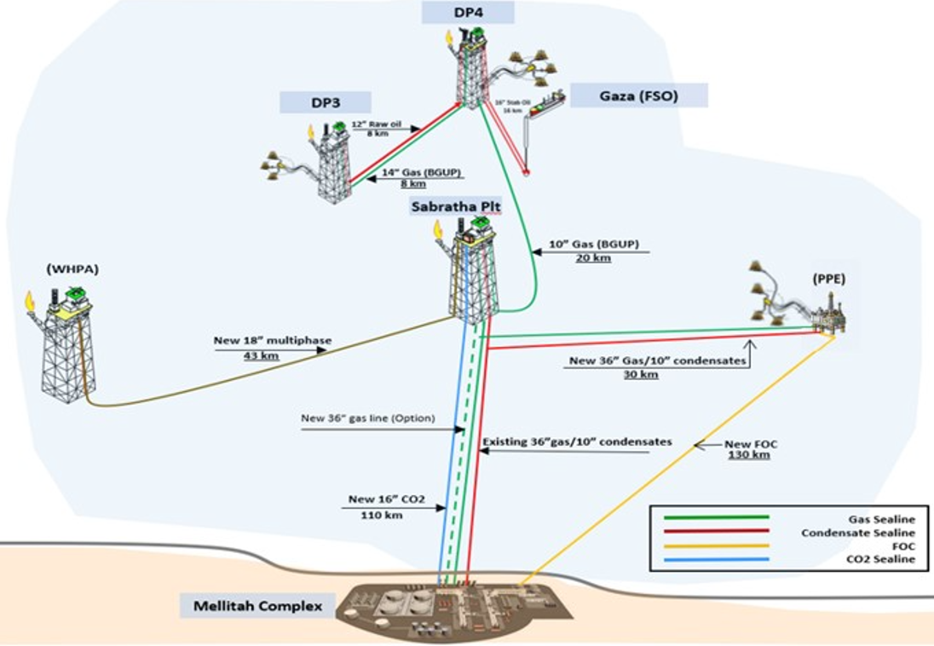

SCHEDULE
The EPIC execution is expected to start by Q3 2027 with Installation campaign of CO2 pipeline and its related subsea system network to be completed by Q2 2029 (Phase 1) and PPE pipeline and its related subsea system network to be completed by Q3 2030 (Phase 2).
Associated Tendering process is planned to occur from Q4 2026 to Q3 2027.

SCOPE OF WORK
It is a turnkey EPIC Contract. The EPIC Contractor’s Scope of Work includes as a minimum Endorsement of FEED Engineering (inclusive of other work packages WP4B2 and WP4B3 which are foreseen to be free issued or novated to CONTRACTOR), the Project Management/Administration, Surveys, material selection, detailed design, Engineering, Procurement, Construction, Fabrication, Testing, Integration Testing, Load-Out, Transportation, Seabed survey and preparation, Laying, Trenching, Installation of Sealine System and Subsea Production system (including all onshore and offshore pipelines, sealines shore approach to MCX, flowlines, expansion spools and wellhead jumpers), tie-ins, Hook up, shore approach, Pre-commissioning, Commissioning, support to Start-up and witness of Performance Test of the following subsea and sealine systems:

From West/North Clusters to PPE
- 6” seamless clad line pipes for PPE production (~ 16 Km), including relevant clad spool pieces (SAWL) and PLETs.
- 16" & 8" seamless clad line pipes for PPE production (~ 7 Km/each), including relevant clad spool pieces (SAWL) and PLETs.4” seamless carbon steel pipes for PPE service (~ 16 Km + ~ 7 Km) including relevant spool pieces and PLETs.
- Rigid well Jumpers
- Flexible Risers for all lines to be connected to PPE.
- PPE North Cluster Manifold & West Cluster PLEM and relevant foundations (free issued or novated from WP4B3): pick-up at Malta, Transportation, Installation & Testing.
- NC/WC 4-off Production X-Mas Trees (free issued or novated from WP4B3): pick-up at Malta, Transportation, Installation & Testing.
- 2-off Subsea Isolation Valves (SSIVs) (free issued or novated from WP4B3): pick-up at Malta, Transportation, Installation & Testing.
- 1-off SSIV Control’s Umbilical and related UTH (free issued or novated from WP4B3): pick-up at Malta, Transportation, Installation, Hook-up & Testing.
- 2-off Umbilicals and related UTHs: (free issued or novated from WP4B3): pick-up at Vendor’s Yard, Transportation, Installation, Pulling, Hook-up & Testing.
- Hydraulic and Electrical flying leads (free issued or novated from WP4B3): pick-up at Malta, Transportation, Installation & Testing.

From PPE to Sabratha Platform
- 36” welded carbon steel gas pipeline from PPE to Sabratha Export PLEM (~ 30 Km) including 36” & 24” spool pieces.
- 10” seamless carbon steel condensate pipeline from PPE to Sabratha Export PLEM (~ 30 Km) including the 10” and 8” spool pieces.
- 2-off Export PLEMs (Gas & Condensate) and relevant foundations (i.e. Gas Export: Preliminary Main frame data: ~ 30m x 19m x 5m and ~365tonnes; Preliminary Protective structure data: ~ 44m x 28m x 5m and ~ 200tons).
- Hot tapping and associated valves and bypass. to connect new gas and condensate export pipeline to existing 36” and 10“ pipelines from Sabratha to Mellitah in a location near to Sabratha Platform.
- Mechanical connectors.
- 2-off Subsea Isolation Valves (SSIVs) (free issued or novated from WP4B3): pick-up at Malta, Transportation, Installation & Testing.
- 1-off SSIV Control Umbilical and related UTH (free issued or novated from WP4B3): pick-up at Malta, Transportation, Installation, Hookup & Testing.
- Flexible Risers for all lines to be connected to PPE

From Offshore to MCX
- 1-off FOC from PPE to Mellitah Complex MCX (~ 130 Km).
- Onshore scope related to WP4B1 items to be installed onshore.
- Hot tapping and associated valves and bypass.
- 36” welded carbon steel gas export pipeline from Sabratha to MCX including relevant Spools (~ 110 Km) (Option).
- Supply of onshore Isolation Joints and Manual Valves at the Mellitah Complex for the Optional 36” pipeline from Sabratha to MCX (Option).

CO2 Network System
- CO2: Concrete coating for Seamless carbon steel pipes for 16” CO2 injection line (~ 5 Km onshore side)
- CO2: 16” seamless carbon steel pipes for CO2 injection including onshore and offshore pipeline, subsea spools, and shore approach; (~ 110 Km) – (free issued or novated from WP4B2): i.e. Endorsement of FEED Engineering, Spools assembly, Transportation from WP4b2 delivery point, Installation, hook-up and testing.
- CO2: Topside and riser pipes and bends for CO2 injection in Sabratha Platform (Optional).
- CO2: Supply of Riser bottom flange and sealine side counter flanges for 16’’ CO2 line to be connected to Sabratha Platform.
- CO2: 1-off Subsea Isolation Valves (SSIV) including riser base flange and counter flange. Pick-up at Malta, Transportation, Installation & Testing (Optional).
- CO2: full EPIC of 1-off Subsea Isolation Valves (SSIV) and related and flying leads inclusive ofLoad-out, Transportation, Installation, pre-commissioning and commissioning of the 16” SSIV (Optional).
- Electrical flying leads (Transportation & Installation).
- Onshore scope related to WP4B1 items to be installed onshore.

  - Project Management, Pre-Commissioning and Commissioning to be carried out by CONTRACTOR and in coordination with other COMPANY’s Contractors and witnessed by the COMPANY. The facilities SHALL be under the responsibility and liability of the CONTRACTOR during the Pre-commissioning and Commissioning until the Ready For Hydrocarbon-in of:
    - All the Sealine Systems (incl. CO2)
    - All the Subsea Production System (incl. CO2)

  - The start-up activities will be carried out by COMPANY and witnessed by the CONTRACTOR. CONTRACTOR will also witness the performance test of the overall facility.

  - The EPIC activities will be defined with the objective to perform the offshore activities with a phased approach by anticipating all what related to CO2 prior to what related to PPE development.

The above SoW includes all related functions, activities and services of each and every kind to accomplish the work, including as minimum; management, supervision, quality assurance, quality control, training, produce as-built drawings/documentation, compile record books, material handling/expediting, preservation, cost control, scheduling, status/progress reporting, interface with Company Marine Warranty Surveyor and Certifying Authority, interfacing with related facilities both Existing and New, interface management in general, provide all labour, resources, tools, equipment, plant, consumables, spares, vendor specialist assistance, accommodation and related infrastructure elements, local content, and implement all safety and environmental requirements.
The following work categories shall be part of the scope of work:

- HEALTH, SAFETY, ENVIRONMENT and QUALITY MANAGEMENT SYSTEMS

- PROJECT Management

- Engineering

- Procurement services

- Construction / FABRICATION / installation / Connections / DIVER ASSISTED & DIVERLESS TIE-INS AND Hook ups / Testing / Pre-commissioning / Commissioning & Start-up.

- Certification, Approvals, Consents and Permits

Important
For the execution of the work described above the Applicant must indicate which part of the scope shall be generated by the Applicant and which part of the scope will be generated by sub-contractors. Possible list of sub-contractors need to be identified at this stage of prequalification in order to be qualified. Applicant to include an high level subcontracting plan identifying key potential suppliers and provide evidence of long-term agreements or letters of intent, if any, for critical scopes (e.g. line pipe suppliers, marine spread and vessels).

In case of Consortium, a consortium agreement shall be provided (identify lead partner, financial responsibility split, liability allocation, decision-making preliminary rules).

It is required that the main core work shall be executed by the Applicant.

Only specialized and original manufacturers for similar oil and gas projects that have proven capability and extensive experience of supplying subsea systems and pipeline systems with specific expertise in offshore hydrocarbons similar projects and in similar water depth will be considered in the Applicant proposals..

The Applicant shall demonstrate strong HSE and Quality performance factors in similar projects and provide their commitment to ensuring that all marine activities at site (including diving and ROV operations) conducted on their behalf are carried out in a safe and efficient manner. The Applicant shall present its performance record, statistics and procedures for all Diving and ROV, Vessel operations over the last 5 years with reference to International Marine Contractor Association (IMCA) guidelines. Applicant to state the preferred tie-in philosophy and expected split between diver-assisted and diverless methods, including assumed weather windows, maximum diver depth limits, and whether IMCA procedures or a project-specific tie-in method will govern

The Applicant shall present its track-record as well on similar project and supply and proposed marine spread suitable for the Scope of Work.

The Applicant shall provide also a preliminary execution time line for supplying the requested material and perform the offshore operations part of the SoW.

